-HOW TO REGISTER
Go to www.seniorscollege.ca and the following page appears.

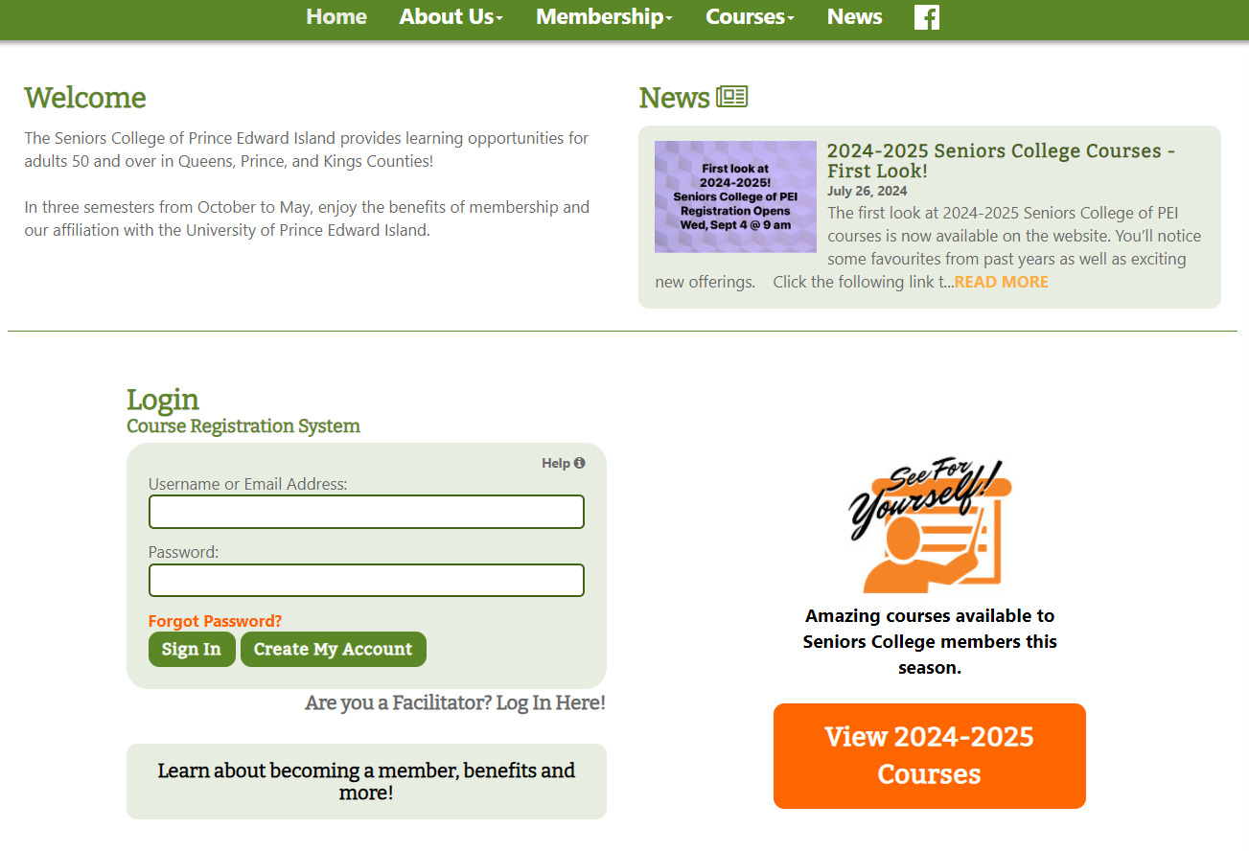

Previous member: Log in Already a Member. Your email address is your username. If you have forgotten your password, click on Forgot Password or email seniorscollege@upei.ca. Note that you can view courses without logging in by selecting View 2024-2025 Courses.
New Member: click Create My Account.

After signing in, the following Member Home Page will appear. Pay your annual Seniors College membership of $170 before registration by clicking on Account Status and follow the steps.
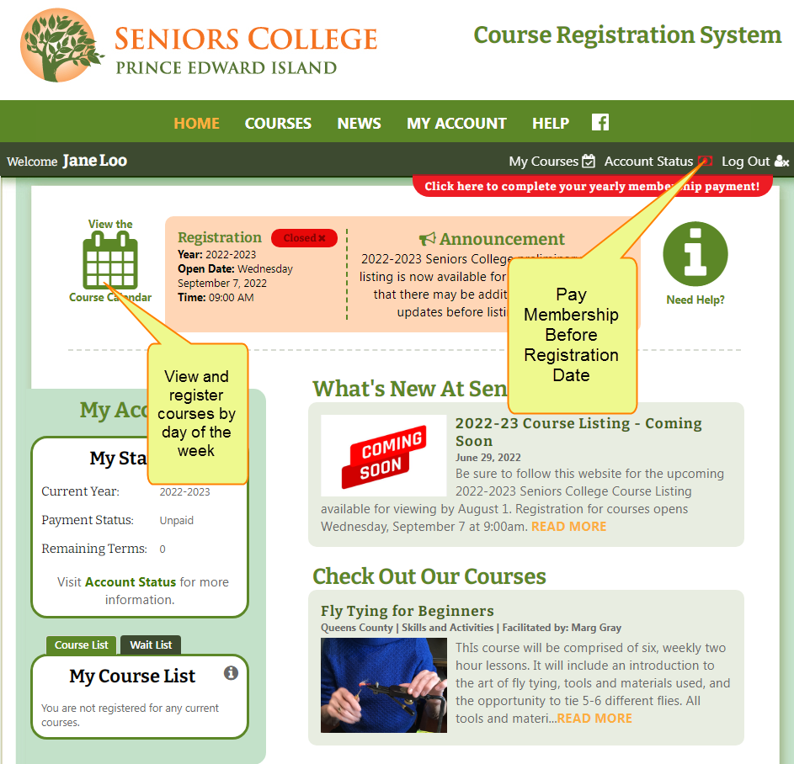

Important Tip: Pay membership before registration date because some courses fill quickly when registration Opens

Pay Membership

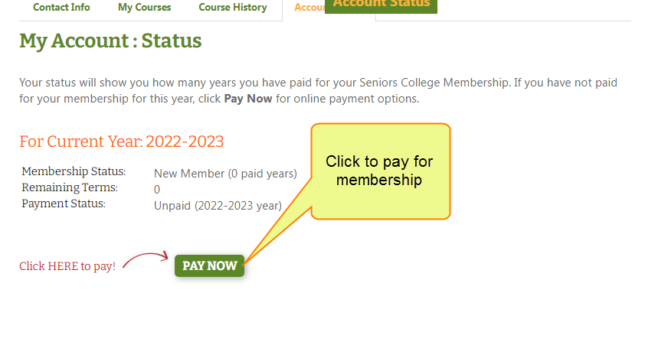
Annual Membership of $170 permits members to register for multiple courses in the upcoming 3 terms.
After clicking Pay Now, the next page is displayed.

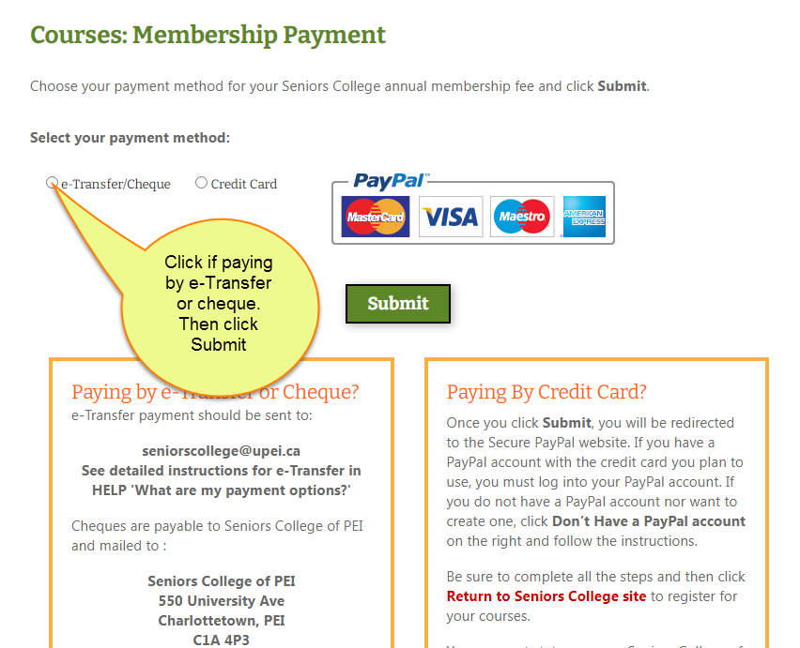
- E-Transfer/Cheques must be sent to the above addresses within 10 days or your account will be cancelled.
- Paying by e-Transfer/Cheque: Important to select e-Transfer/Cheque payment method to set your account to ‘Paid -payment pending’ and permit you to register before payment is received by Seniors College.
- Include your member name on e-Transfer/cheque information line.
- Paying by credit card: Use your PayPal account if you have one, create a Paypal account or use your credit card without a Paypal account. If the credit card you plan to use is already attached to a Paypal account, you must sign into your account.

My Account: Status

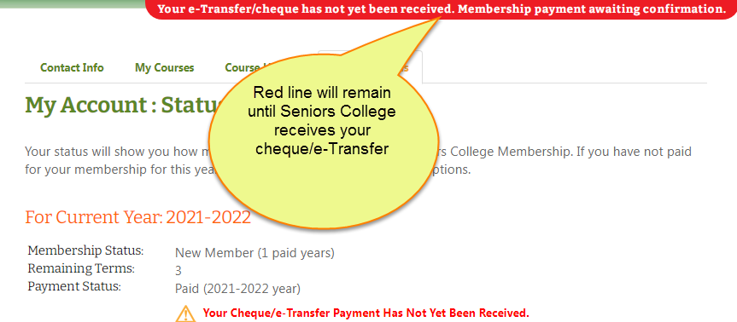

Course List Legend – New Icons
In addition to One Day Course and Additional Cost icons, two new icons in Legend identify Online and Hybrid courses.
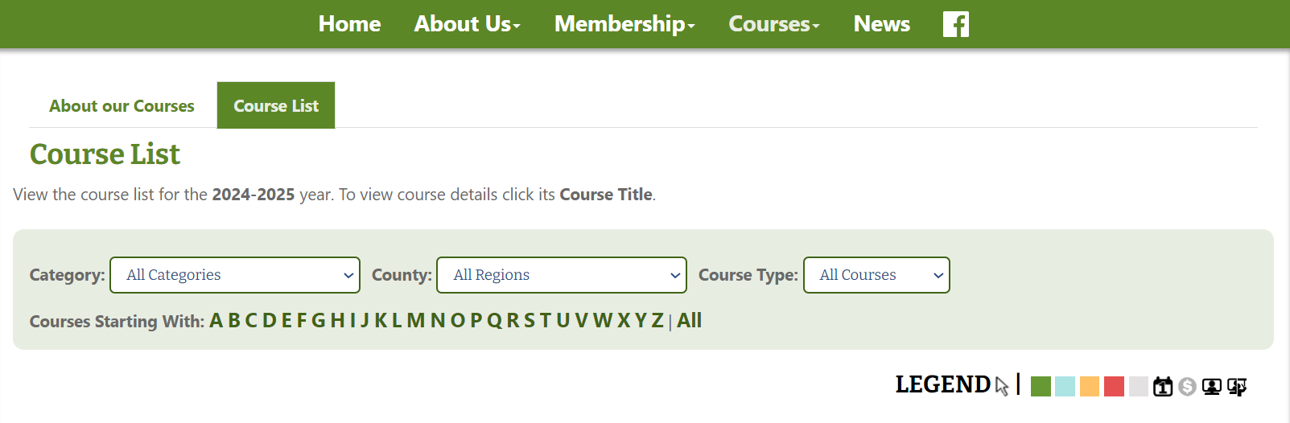
Course is presented Online this term:
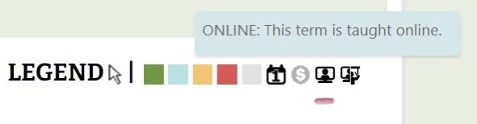
Course is presented Online and In Person this term:
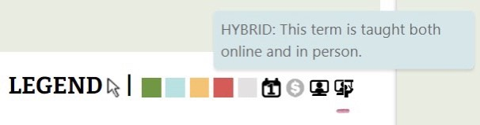

Important note: Some of the following screenshots show previous years; however, the instructions are correct.
View Courses by Course List (alphabetically) or Course Calendar (day of the week). Both options can be filtered by Category and County.

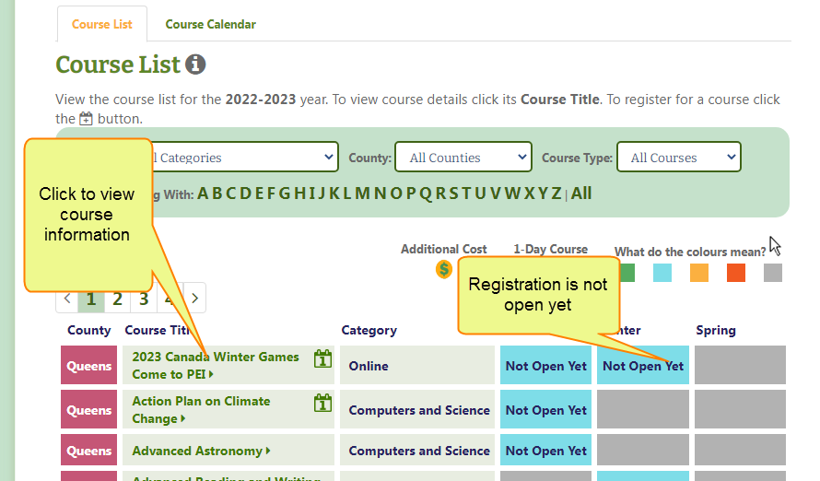

Registration opens on September 4, 2024 at 9 am. Not Yet Open will change to Open  Click on it to Register.

Registering for courses
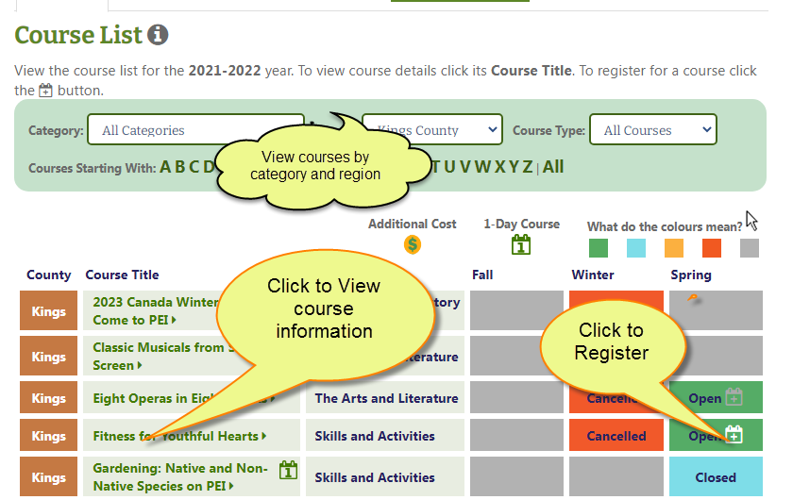
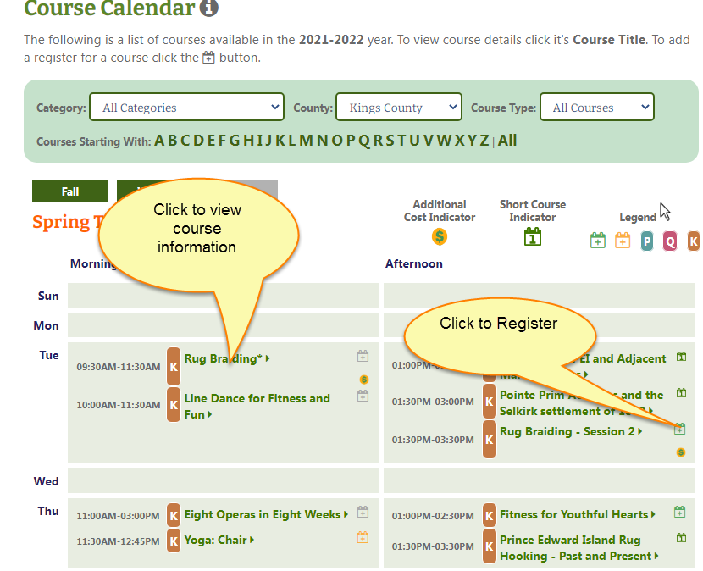
To view, print or cancel your courses, go to My Account, My Courses
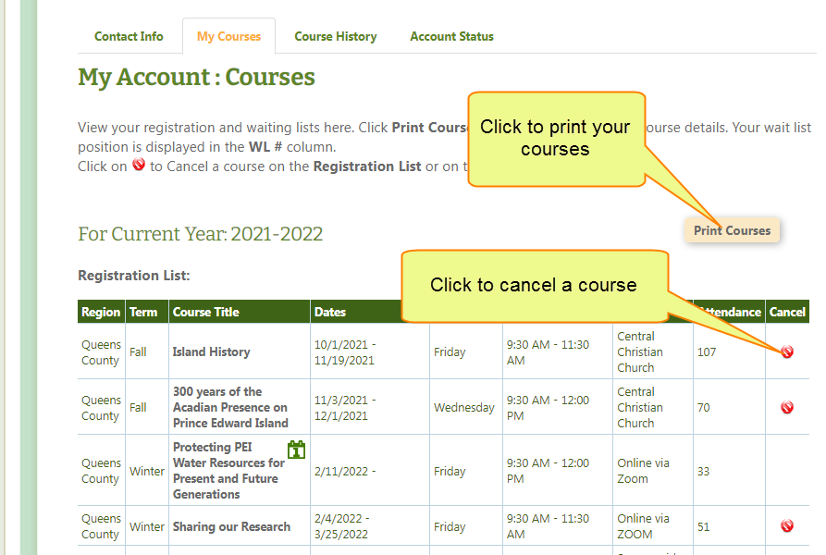

Change your password, email address or any information in your account by clicking My Account/Contact Info. It is important that your email address is up to date to receive information from Seniors College.
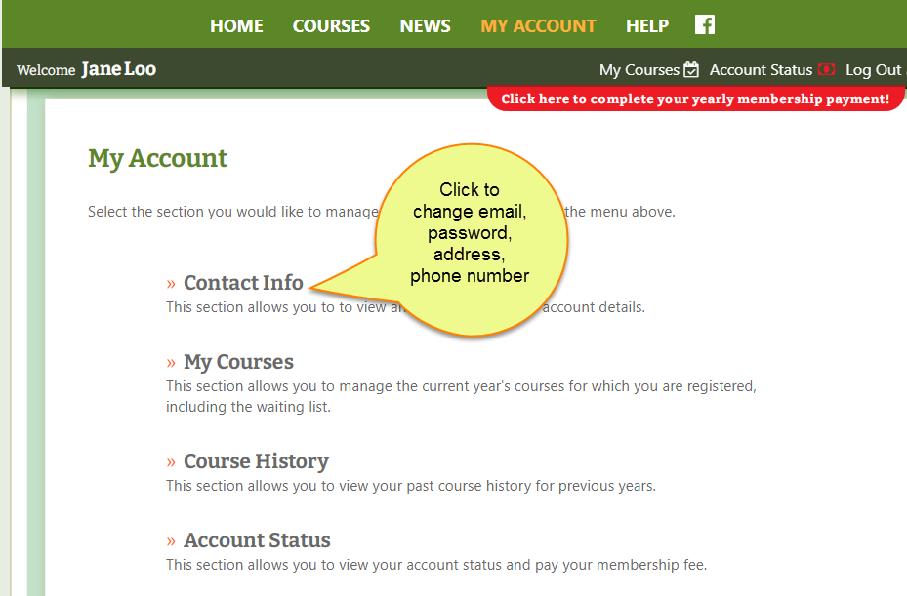

Logout when finished.

